 | TAFL  (ACSE-0404)  UNIT-I |  | SESSION: 2021-22
 |  |  | CLASS/SEM: B.Tech CS/AIML IVth (EVEN)
Assignment Given Date: 09/03/2022  Assignment Submission Date: 20/03/2022 |  | Maximum Points: 10
 |  | Weightage in University Exam:
Faculty Name: Sonia Arora |  | Faculty Mail Id: soniaarora@niet.co.in
Note: Write solution of each question in clear handwriting.
1 a. Define finite automation? Give the examples.
1 b. Enumerate the differences between DFA and NFA.
2. Construct a DFA accepting binary strings such that the third symbol from the right end is 1.
3. Construct NFA without ε - transitions for the NFA given below.
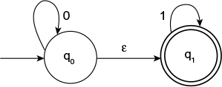
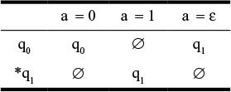
4. Construct NFA accepting binary strings with two consecutive 0’s.
5. Construct an NFA without ε - transitions for the following NFS.
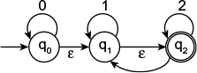
6. Construct an NFA for the following regular expression: (a + b)* a + b (8)
7. Give Deterministic finite automata accepting the following language over the alphapet.
  - Number of 1’s is a multiples of 3
  - Number of 1’s is not a multiples of 3

- Prove the equivalence of NFA and DFA using subset construction.

